
🧺 Snack Bag Packing Project — Design Brief (100 Bags)
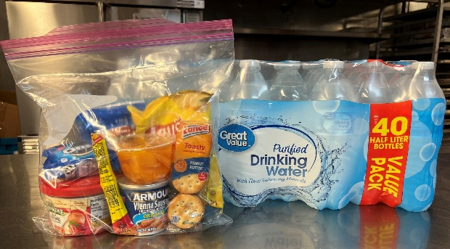
1. Project Overview
- Purpose: Assemble 100 individual snack bags for distribution at JCOC’s community dinner. Bags will be offered to dinner guests, in addition to their meal, as supplies allow.
- Bag type: 1-gallon clear plastic storage bags (e.g., Ziploc or Food Lion brand).
- Goal time: ~1.5 hours total (20 min setup, 45 min packing, 20 min cleanup).
- Team: 20 volunteers working in organized packing stations.
- Location: Large room with at least 3 long tables and open movement space.

2. Shopping List (Food Lion prices where available)
Item | Qty (100 bags) | Approx. Unit Price | Est. Total | Notes
Canned Meat (pop-top or pouch) | 100 | $0.79 | $79.00 | e.g., Vienna Sausage or Chicken Salad pouch
Chips (snack-size bags) | 100 | $0.89 | $89.00 | Variety pack or single flavor
Cookies (snack packs) | 100 | $0.50 | $50.00 | Mini packs or 2-cookie sleeves
Granola Bars | 100 | $0.42 | $42.00 | Nature Valley or store brand
Crackers (snack-size) | 100 | $0.50 | $50.00 | Peanut butter or cheese crackers
Fruit Cups | 100 | $0.99 | $99.00 | Includes plastic spoon if possible
Meat Sticks | 100 | $1.29 | $129.00 | Slim Jim or Jack Link’s singles
Water or Juice Boxes (small) | 100 | $0.35 | $35.00 | 6.75 oz juice boxes or 8 oz water
Gallon Storage Bags | 100 | $0.12 | $12.00 | Food Lion or Ziploc 1-gallon 100 ct pack
Total Estimated Cost: ≈ $585.00
(based on Food Lion averages — prices vary slightly by region)
Optional Add-ons:
- Napkins (100 ct pack): $3.00
- Plastic spoons for fruit cups (100 ct): $4.00
Grand Total (with add-ons): ≈ $592.00
Note: 100 snack bags is the recommended goal. Adjust quantity as needed for your budget.

3. Packing Specifications
Each gallon bag will contain:
- 1 Canned Meat (pop-top or pouch)
- 1 Bag Chips
- 1 Cookie Pack
- 1 Granola Bar
- 1 Cracker Pack
- 1 Fruit Cup
- 1 Meat Stick
- 1 Small Water or Juice Box
Tips:
- Place heavier items (canned meat, juice) on the bottom; lighter snacks on top to prevent crushing.
- Avoid including items that need refrigeration.

4. Volunteer Roles & Setup (20 People)
Role | # Volunteers | Duties
Setup Crew | 3 | Unpack groceries, label tubs, prep stations
Packing Line Stations (A–E) | 10 | Add assigned items to bags in sequence
Quality Check & Bag Sealing | 3 | Verify item count, seal, stack bags
Refill & Supply Runners | 2 | Keep tubs stocked, remove trash
Cleanup Crew | 2 | Collect boxes, wipe surfaces, stack finished bags
Layout:
Set up five stations in order, assembly-line style:
- Station A: Canned Meat + Meat Stick
- Station B: Crackers + Granola Bar
- Station C: Cookies + Chips
- Station D: Fruit Cup
- Station E: Juice/Water + Seal Bag

5. Timeline
Task | Time (Minutes)
Setup (unpack, label, prep) | 20
Packing (100 bags) | 45
Quality Check & Stacking | 15
Cleanup | 20
Total Project Time | ~1.5 hours

6. Instructions for Volunteers
Before Starting:
- Wash or sanitize hands.
- Review example completed bag at Station E.
- Stand by your assigned station.
- Listen for the team lead’s “start” signal.
During Packing:
- Each volunteer adds only their assigned items.
- If a tub runs low, call a supply runner.
- Keep bags open until final sealing station.
- Communicate clearly down the line to keep the process smooth.
After Packing:
- Stack filled bags in sturdy boxes or bins (10–12 per box).
- Count all bags before cleanup.
- Dispose of packaging, flatten cardboard, and sanitize tables.

7. Visual Guide (Display or Print at Each Station)
Option A: Assembly Line
- Station A: Meat Items – Add 1 canned meat + 1 meat stick → Pass to B
- Station B: Dry Snacks – Add 1 granola bar + 1 cracker pack → Pass to C
- Station C: Sweet Snacks – Add 1 cookie pack + 1 chips bag → Pass to D
- Station D: Fruit Cup – Add 1 fruit cup (with spoon if available) → Pass to E
- Station E: Drink & Seal – Add 1 juice box or water, seal bag, hand to Quality Check
Option B: Individual Bag Packing
- Take an empty bag.
- Add items in this order:
  - Canned meat (pop-top)
  - Meat stick
  - Granola bar
  - Cracker pack
  - Cookie pack
  - Chips bag
  - Fruit cup (with spoon if available)
  - Juice box or water bottle (small)
- Seal the bag tightly.
- Hand to Quality Check.
Tip: Individual packing is ideal if tables or stations are limited.

8. Quality Check Procedure
- Confirm all 8 items are inside.
- Ensure bags are sealed flat (no air).
- Stack neatly in boxes labeled “Snack Bags – 100 count.”
- Store in a cool, dry place.

9. Equipment Checklist
✅ Folding tables (3–4)
✅ Hand sanitizer
✅ Gloves (optional)
✅ Trash & recycling bins
✅ Permanent markers for labeling
✅ Plastic tubs or boxes for sorting items
✅ Timer or speaker for instructions

10. Delivery Coordination
For scheduling the delivery of snack bags, contact:
Krishna Loya, Community Engagement Manager
📧 kloya@jcoc.org | 📞 (757) 491-2846

