The Police and Princess Ball, organized by the New Castle County Police Dept, is a heartwarming community initiative aimed at fostering positive relationships between law enforcement and the community. This event, which began in 2018, has grown significantly and is now a cherished tradition. It primarily targets young girls from the Edgemoor Gardens community, typically in grades Kindergarten through 6th. These girls are treated like princesses for the evening, donning formal dresses, riding in limousines, and enjoying a night of dinner and dancing at the upscale Waterfall Banquet and Conference Center in Claymont, Delaware. | 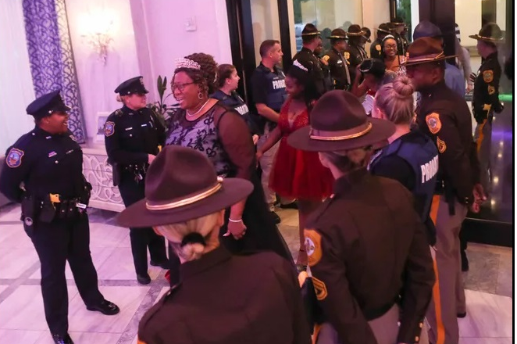
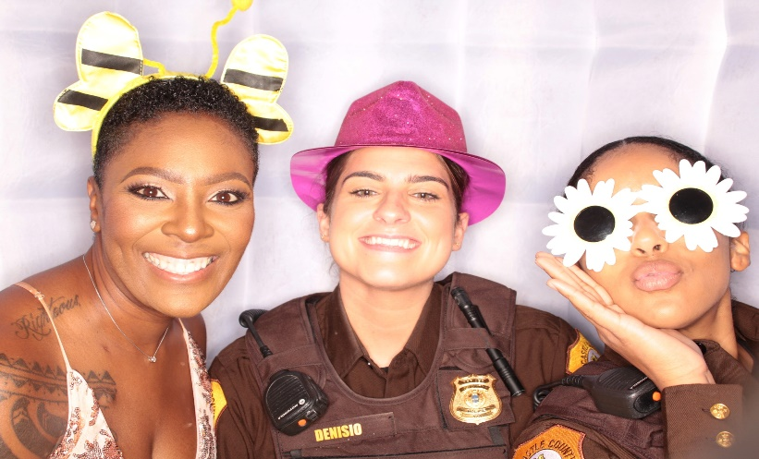 | Police officers from various local agencies, including New Castle County, the University of Delaware, the city of Wilmington, Delaware State Police, and Delaware Probation and Parole, actively participate in the event. Their involvement is crucial in breaking down barriers and fostering trust within the community. The event is largely supported through donations and run by volunteers, including members of the Bellefonte Lions Club. This community-driven support underscores the collective effort to make the evening special for the young participants.
The selection process for the girls who attend the ball is community-focused, with officers who work in the Edgemoor Gardens area playing a key role in identifying and inviting the girls. Local organizations like the Edgemoor Revitalization Cooperative and the Bellevue Community Center also support this process, ensuring that as many girls as possible feel special and valued. Around 120 girls from across Delaware, mostly aged 6-13, attend the event, which includes performances by groups like Delaware State University’s award-winning step team, iSTEP. | 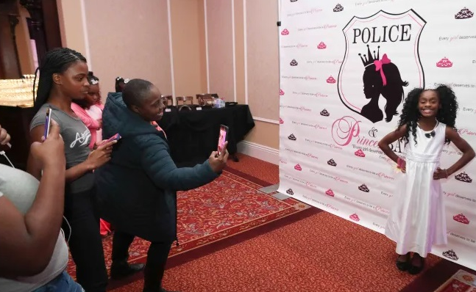
 | 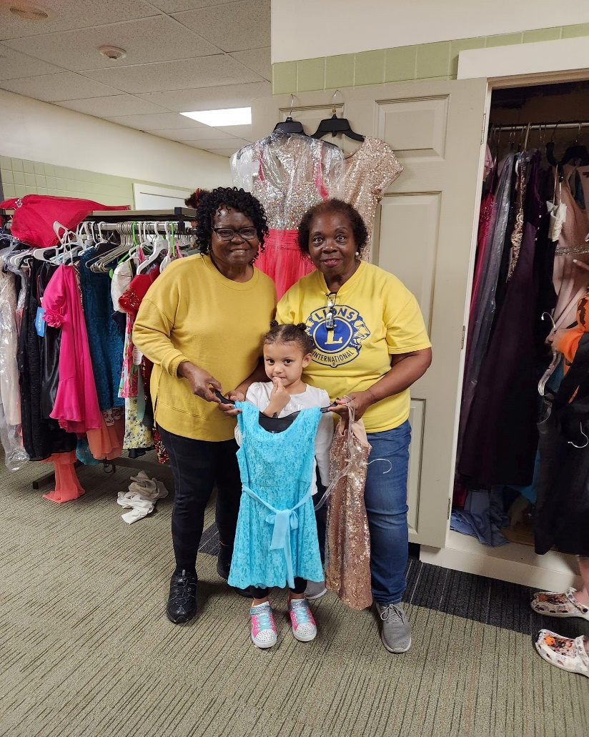
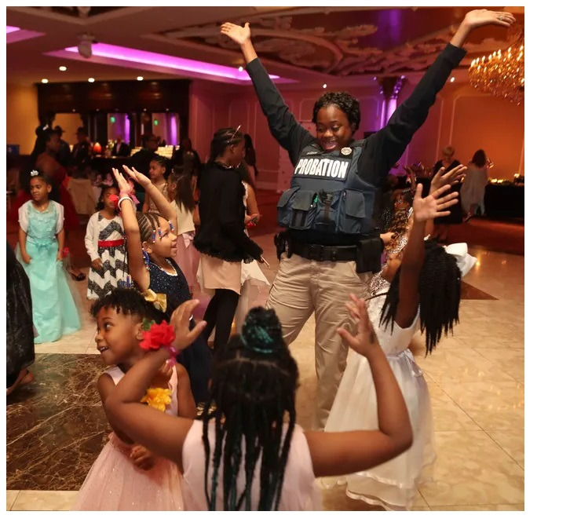 | The impact of the Police and Princess Ball on the community has been profound. It has changed attitudes towards law enforcement and provided a memorable experience for the young participants. The event is not just about a night of fun; it’s about building lasting relationships and trust between the police and the community. The formal dinner, enjoyed alongside police officers and other local law enforcement, adds to the special treatment the girls receive, making the evening even more memorable. This initiative is a shining example of how community engagement can bring joy and strengthen bonds between residents and law enforcement.  The ____________________ Lions Club would love to start a Lions Club of members that run this event and others to help people in the ___________ Community.  Lion Police Sargent Tracey Duffy from Delaware Police will be speaking to us and we would love for you to attend.
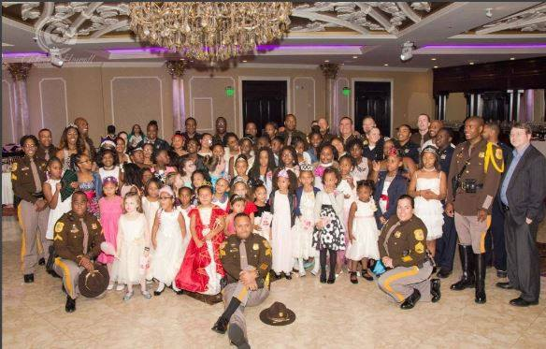

Contact Mack Stevens
757-621-9074 for more info

